**DAILY ONLINE ACTIVITIES SUMMARY**

|  |  |  |  |  |  |  |  |  |
| --- | --- | --- | --- | --- | --- | --- | --- | --- |
| **Date:** | **16 June 2020** | | | | | **Name:** | **Sana F Habib** | |
| **Sem & Sec** | **6th sem & B sec** | | | | | **USN:** | **4AL17CS081** | |
| **Online Test Summary (DAY 2-Workshop)** | | | | | | | | |
| **Subject** | | Pre-Placement Training 9:15 am to 11:00 am - Programming in C  11:15 am to 1:30pm - Applications of python in DA and ML | | | | | | |
| **Faculty** | | 1.Merlyn Mathias  2.Dr.Mohideen  Badhusha | | **Duration** | | | **4 hours** | |
| **Certification Course Summary** | | | | | | | | |
| **Course** | **Career Edge** | | | | | | | |
| **Certificate Provider** | | | **TCS** | | **Duration** | | | **15 days** |
| **Coding Challenges** | | | | | | | | |
| **Status: Executed** | | | | | | | | |
| **Uploaded the report in Github** | | | | | **YES** | | | |
| **If yes Repository name** | | | | | [**https://github.com/sanahabib2409199/Sana-F-H.git**](https://github.com/sanahabib2409199/Sana-F-H.git) | | | |
| **Uploaded the report in slack** | | | | | **YES** | | | |
| Applications of python in DA and ML  (Dr.Mohideen  Bahasa) | | | | | [**https://github.com/sanahabib2409199/Python-Worshop.git**](https://github.com/sanahabib2409199/Python-Worshop.git) | | | |

Certification Course Details: (Attach the snapshot and briefly write the report for the same)

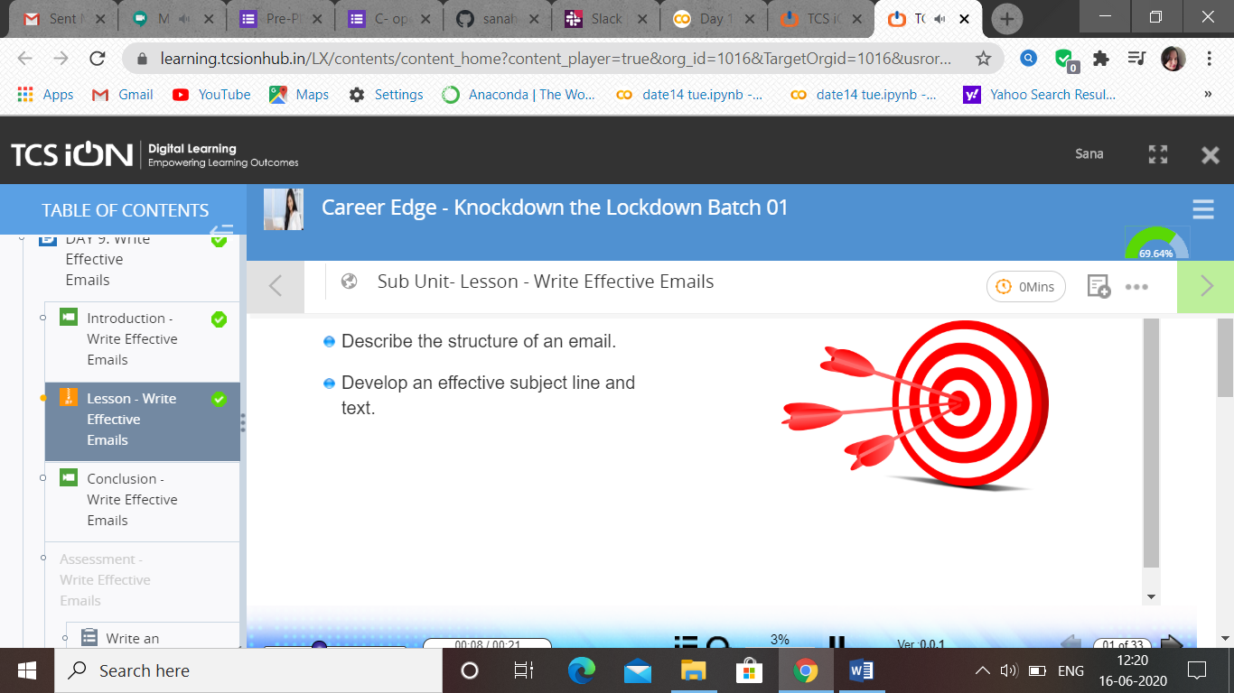

(16-06-2020)-Career Edge. TCS-Write Effective Emails.

### >>DAY 2- Programming in C….. And Workshop- Applications of Python Programming in Data Analytics and Machine Learning – Research Perspect.

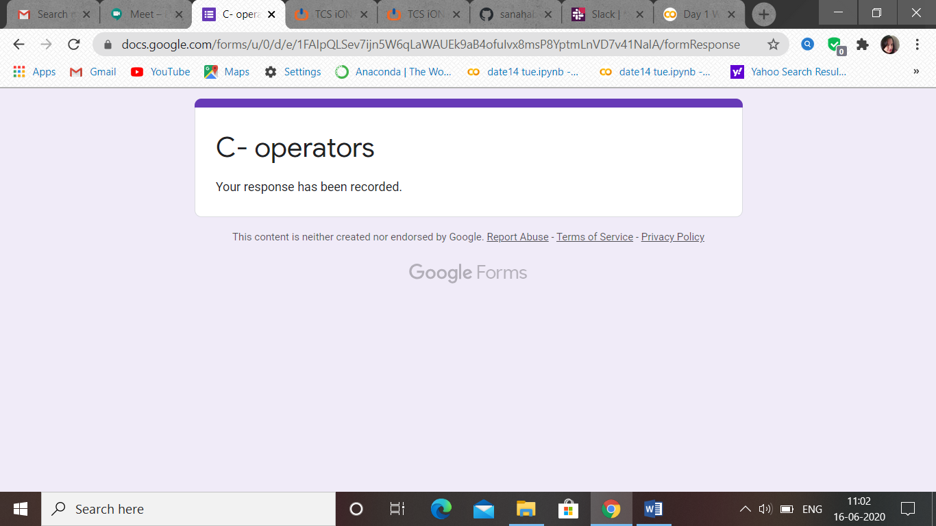

Quiz (Only one quiz I took …due to technical issues I was not able to attend previous quiz of today’s-Programming in C)

SESSION 1

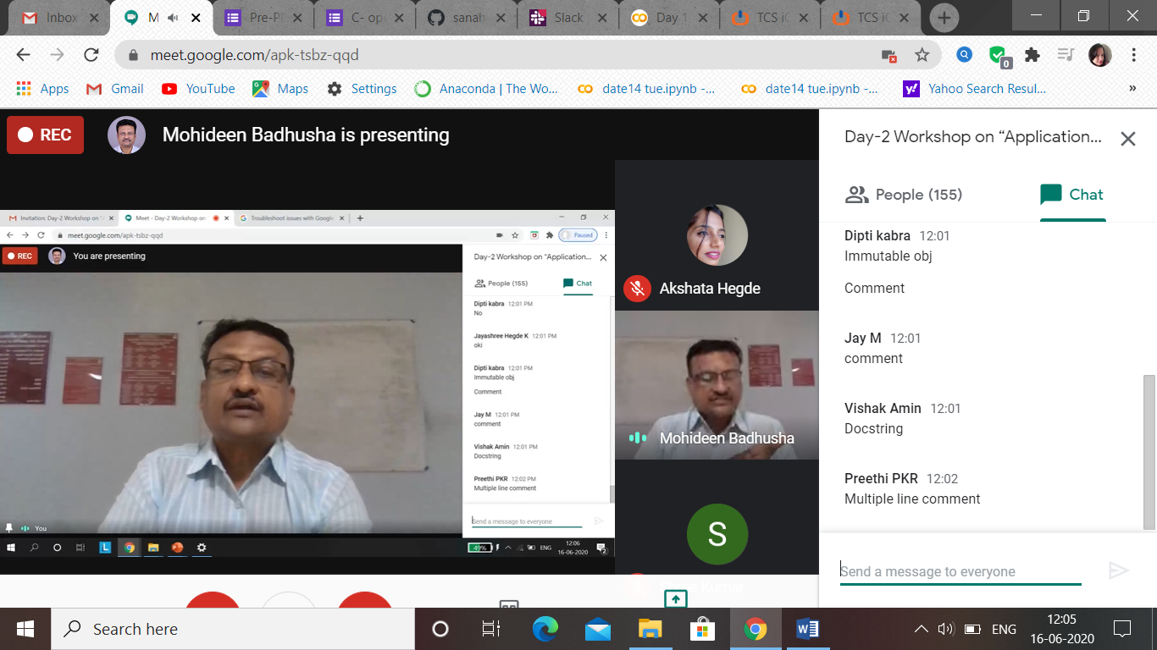

SESSION 2

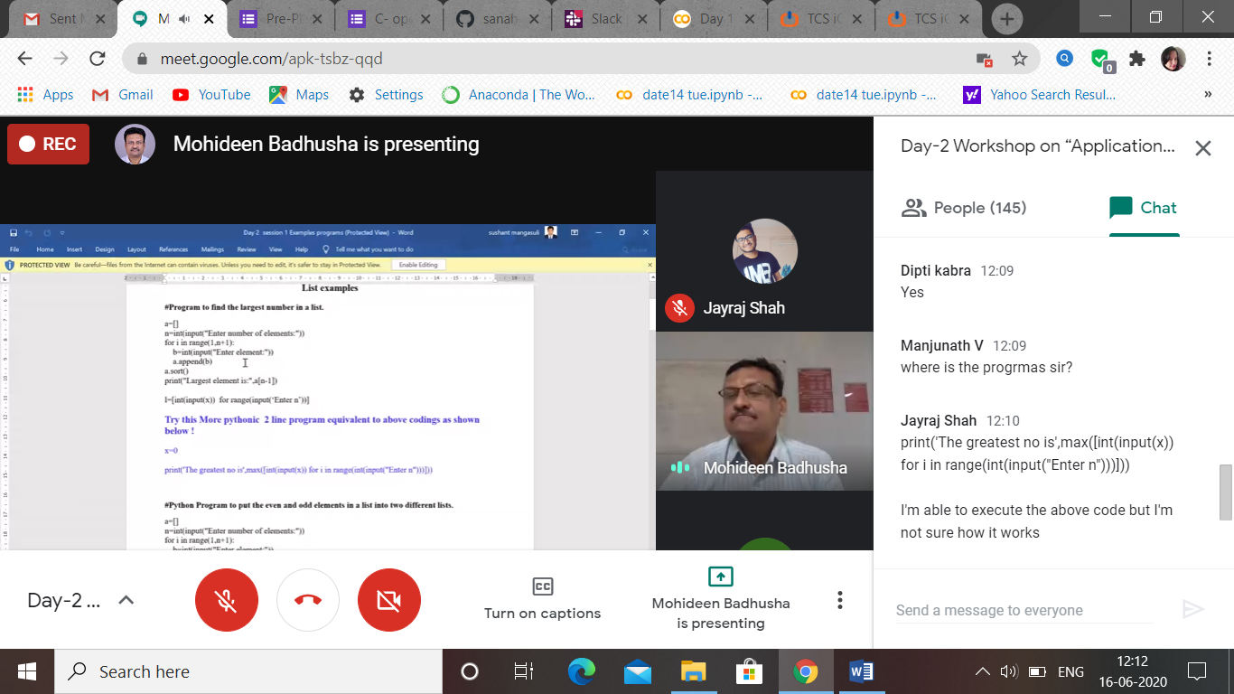

Workshop –Exercise (day 2)

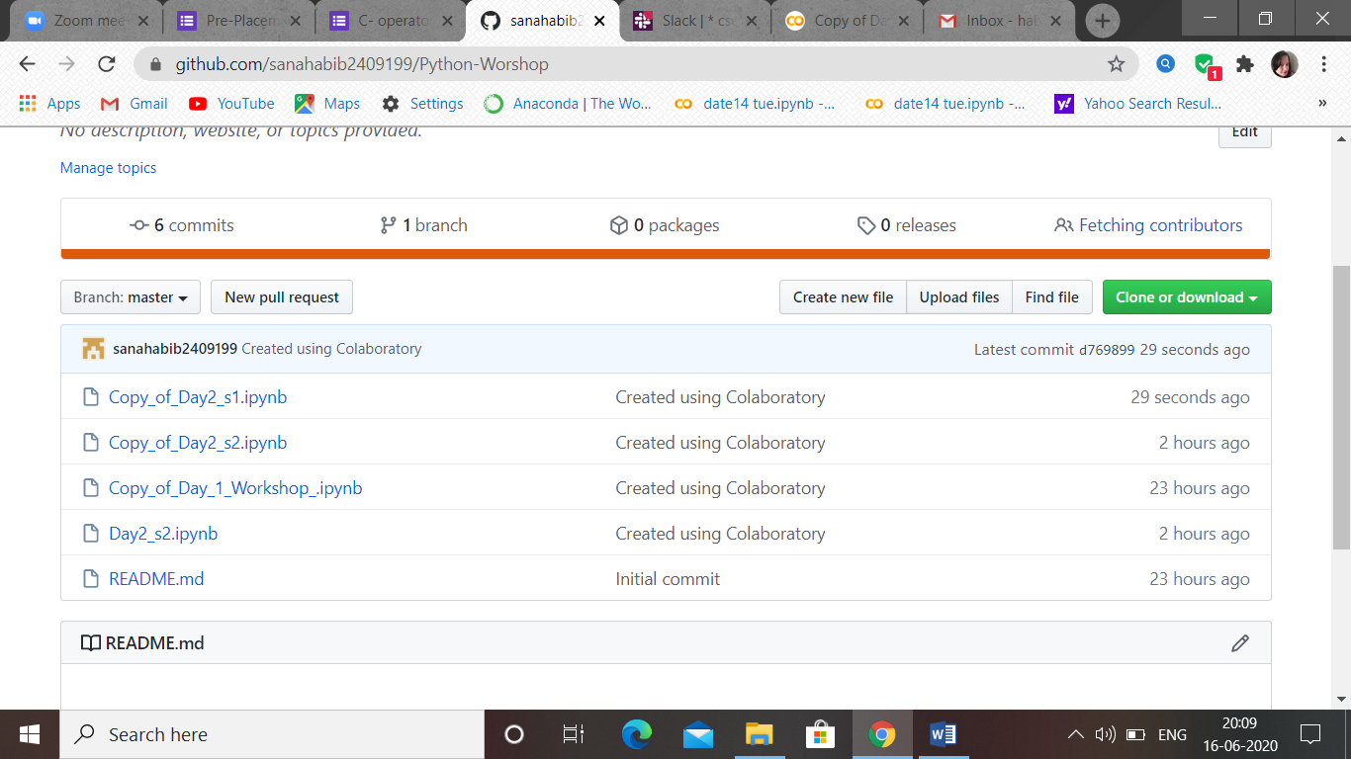

Quiz: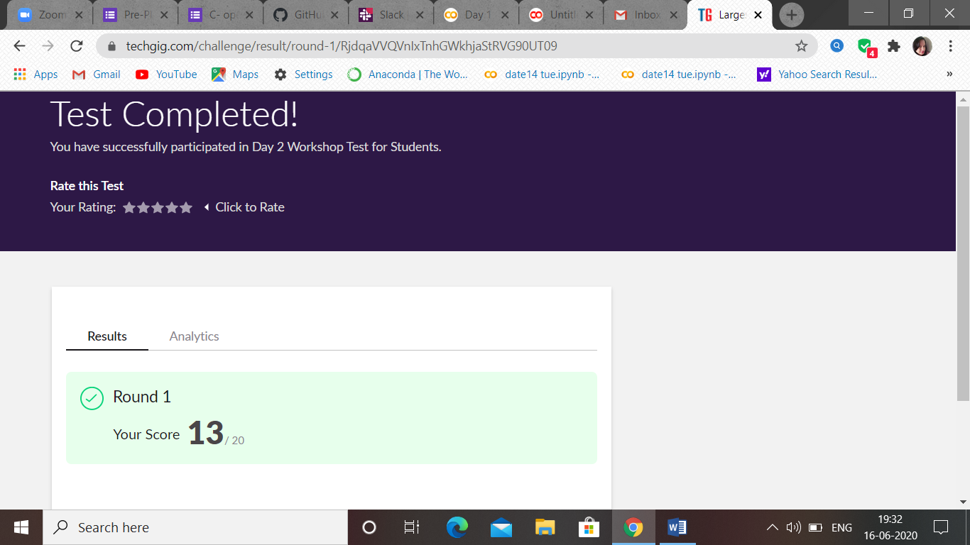

Coding Challenges Details: (Attach the snapshot and briefly write the report for the same)

